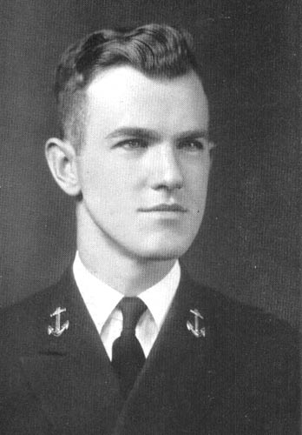Born John Michael Sullivan on May 15, 1890, in Brighton, Mass, to John and Kathleen Sullivan.  Jack, as his parents called him, is the 6th of 7 children and the 3rd of 3 boys.

Not long after he was born, his family moved into Boston.  There he attended Boston College from grade school through college (Boston College originally consisted of a grade school, high school, and college.)  Jack was an indifferent student.  From 1908-1910, Jack studied engineering at Boston College, but he did not complete any degree.

In 1909, Jack became involved in boxing.  He thought it might be a good way to make extra money.  His career lasted about 18 months before he moved on.  During his time as a boxer, he gained the nickname "Sully"--sometimes being jokingly referred to as "Savage Sully" or "Sleeping Sully" (if he had just lost a match.)

Also, at this time, he started dating a girl from a wealthy Bostonian family.  While the relationship with Aemelia was short lived and volatile, he ended up becoming friends with the girl's father.  Her father, Archibald Ellsworth, shared an interest in boxing.  Before long, Mr. Ellsworth was treating Sully like a son.  Mr. Ellsworth started bringing Sully along on hunting trips up in New York, Vermont, New Hampshire, and Maine.  This is where Sully started to learn his shooting and survival skills.

Before long, Sully was being hired as "muscle" for other hunting trips being arranged by the wealthy of New England and Mid-Atlantic states (namely cities like Boston, New York, Washington, and Philadelphia.)  At first the hunting trips were in the North East states.  Shortly, he began travelling out West.  And within a year or two, Sully was traveling to places like Central America, South America, and Africa.  All this occurred from late 1909 through 1915.

In 1912, Mr. Ellsworth thought it might be useful to have some individuals with piloting skills as part of his hunting party.  He paid for Sully (and a couple others) to train to become pilots.

In March 1914, Sully was in New York City.  While there he was invited to a party where he exchanged harsh words with and punched the young attaché of the Imperial German ambassador after an argument.  It caused many of the hunting trip patrons to begin viewing Sully as a crude hot blooded Irisher.  This began to make it more difficult for Sully to find work.

In late 1914, Sully was approached by one of Mr. Ellsworth's colleagues.  He was told that the Marines had been forming an Air corps and were looking for capable pilots.  Sully jumped at the chance to do more flying and signed up with the Marine Air Corp.

Sully served in the Marines from 1915 to 1917.  He reached the rank of Lieutenant.  His career ended after a week in which he had 4 aero plane crashes.  He was drummed out of the corps when it was determined that the accidents were all the fault of pilot error and negligence.  Sully is convinced that possibly one crash was due to his error, but there was something odd about all the accidents.

Sully is in Arkham, Mass, largely because of Miskatonic University.  He has heard that they often send out expeditions and figures they might just need someone with his skills.  During his time as an adventurer (as he likes to refer to it) and a marine, he worked a lot but did not have much chance to spend his wages.  So, he does have a comfortable savings that allows him to wait a little while to find work--as long as he is careful about his expenses.

Sully was drawn to the Crown and Shield after hearing about it from one of its members.  During his time in places, like Africa, he heard of and saw some unusual and sometimes disturbing things.  He likes being with people who don't simply write it all off as fairy tales or fantasy.  While he does feel a sense of dread at some moments, he is curious to learn the truth of these things.

Editing Notes

* Sully probably is 3rd generation Irish-American.  Statistically, grandparents were likely to have moved into the U.S. during the 1840-1850's.
* At this time, the stereotype of Irish-Americans is pretty negative--lazy, hot blooded, impulsive, drunken, and criminal (usually reporting to some "boss")  Sully is likely to try to be sensitive about and try to distance himself from the stereotype.
* Not certain that Boston College offered an engineering degree during this timeframe--although not likely to be too important to the character since he didn't study much.
* Still need to look up information on planes from 1908-1918 to see which ones Sully most likely flew.
* Still uncertain where the Marine Air Corp was stationed from 1915-1917.  Think maybe Washington D. C. area.  However, they would have relocated to Puerto Rico in 1917--it seems.